Pond Square Chapel - Christmas Services for Dec 21/Jan 22

Also check Website – www.pondsquarechapel.org.uk;
and YouTube channel Pond Square Chapel – some services streamed live

Sunday 5th December

10.30 am - Service of Holy Communion

4.30 pm - Christingle Event - all welcome

Sunday 12th December

10.30 am - Nativity Service for all the Family, with Brass Band

Sunday 19th December

10.30 am - Service of Carols and Lessons - all Welcome

Christmas Eve - Friday 24th December

6.30 pm - Family Service by Candlelight

Christmas Day - Saturday 25th December

10.30 am - Christmas Day Family Service

Sunday 26th December

10.30 am - Service for Last Sunday of the Year

Sunday 2nd January 2022

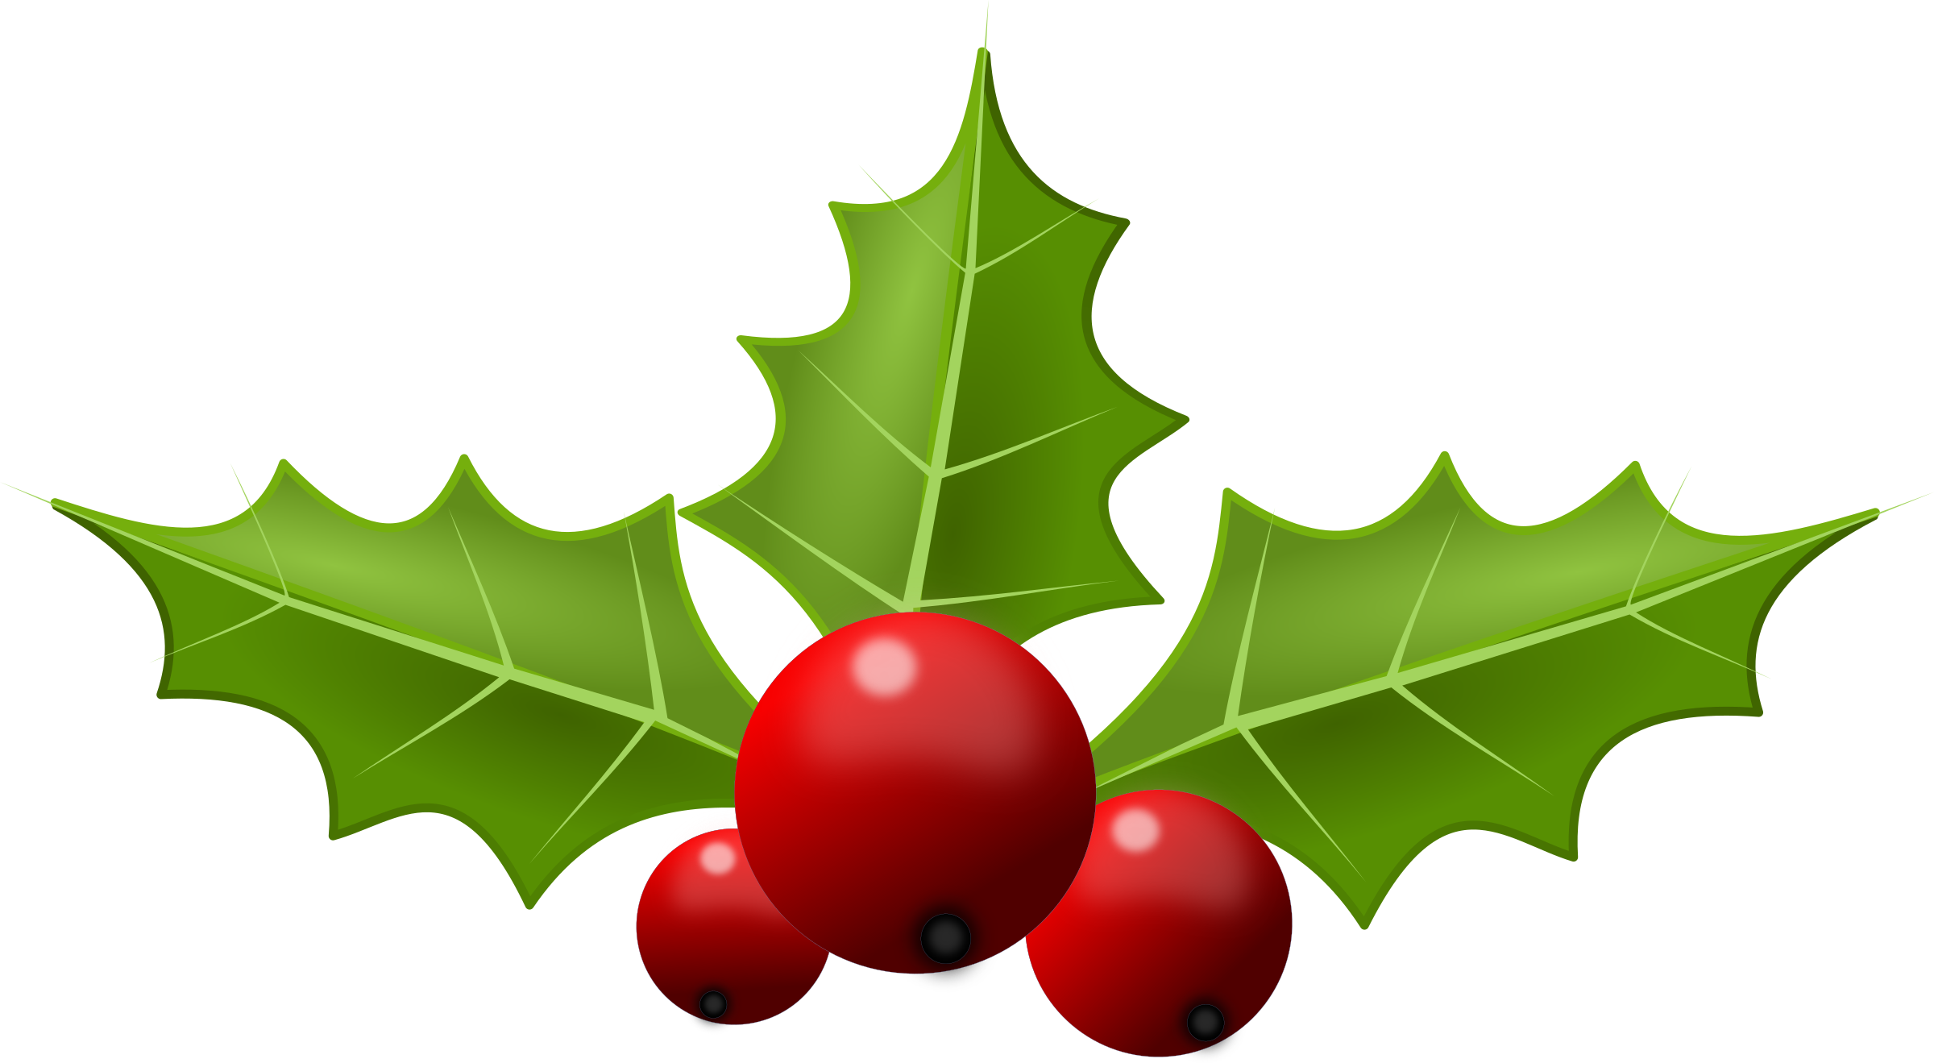
10.30 am - Service for First Sunday of the New Year

